**Assignment Title**: BTEC Level 2 Extended Certificate in ICT – Unit 13: MobileWorldStation Website.

**Website 2:** thebigphonestore.co.uk

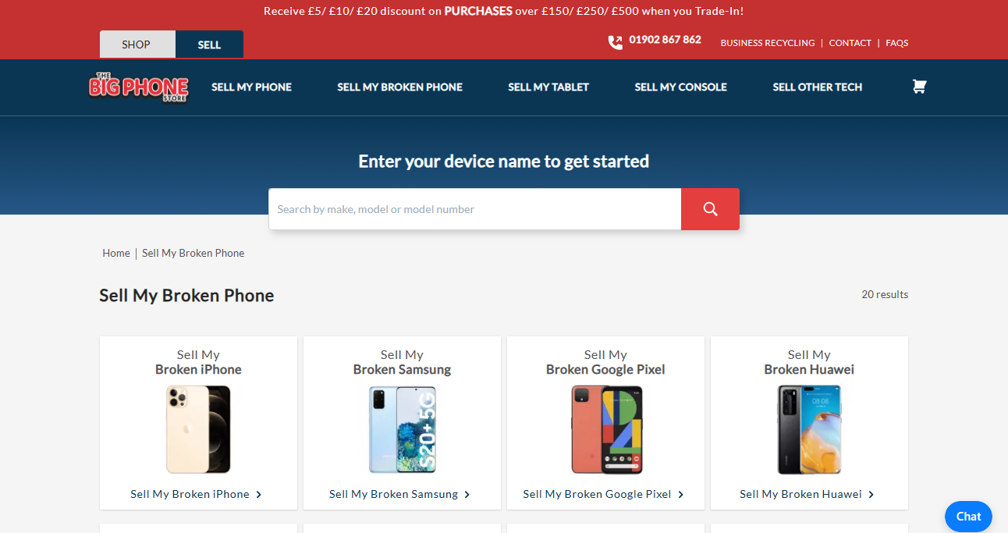

SEARCH BOX

CONTACT OPTION

HYPERLINKS/MENUS

HOTSPOTS

ACCOUNT OPTIONS

**Overview (**Of the Website**):**

The Big Phone Store is an ecommerce website and a company that sells, buys used and broken devices such as refurbished smartphones, tablets, smartwatches and lots more from the world’s most popular brands such as; Apple, Samsung, Huawei and Google. The main goal of the company to save the environment and save their customer’s money.

**Uses:**

The primary use of this website is to buy used/broken and sell gadgets to customers. It involves [selling phones](https://www.thebigphonestore.co.uk/trade-ins/sell-my-phone), [selling broken phones](https://www.thebigphonestore.co.uk/trade-ins/sell-my-broken-phone), [selling tablets](https://www.thebigphonestore.co.uk/trade-ins/sell-my-tablet), [selling consoles](https://www.thebigphonestore.co.uk/trade-ins/sell-my-console) and [selling other tech](https://www.thebigphonestore.co.uk/trade-ins/sell-other-tech). These are also accessible from the taskbar running across the top of the website.

* Selling Phones (**Buying from a user**)**:** The major services of the website are to buy phones some users. It’s a process whereby the user selects places an order and they will be directed to a product page for the model they wish to sell, then the user sends their phone and when it’s received by the company the user gets paid instantly.

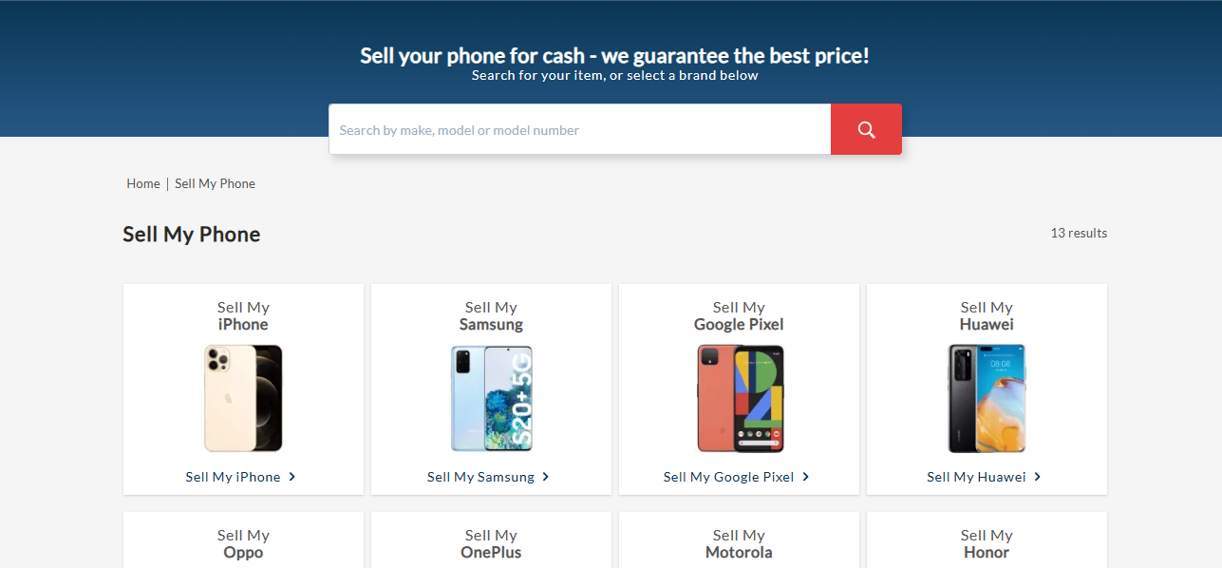

* Selling broken phones **(Buying from a user**):

Another section of the big phone store website is buying broken phones from a user. It’s similar to selling a phone option apart from the fact that, the phone the user wants to sell is broken or have got an issue such as a cracked screen, a water damaged board and more.

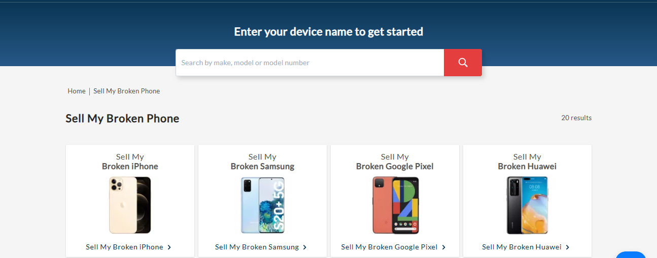

* Selling other Tech Gadgets **(Buying from a user**):

The big phone store website also buys other tech gadgets from users who are willing to sell. Some of these gadgets include; Laptops, tablets, game consoles, Cameras and other tech gadgets.

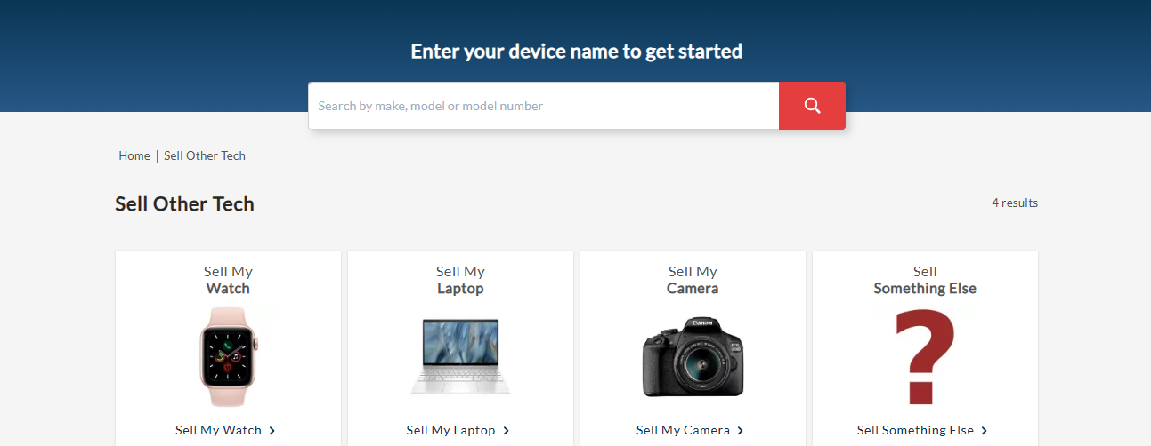

* Shopping (**Selling to customers**):

The website also offers a whole section that allows users to buy both new and refurbished tech gadgets such as; phones, tablets, Laptops and other accessories at affordable prices. The company also offer flexible payment to users depending on their choices.

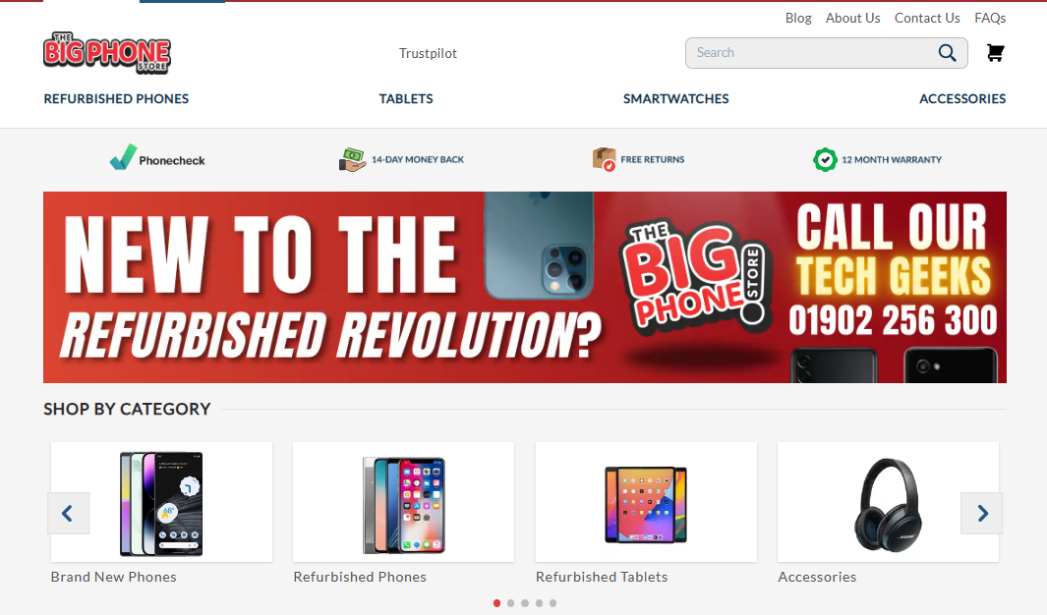

**Features:**

Colour Scheme:

The colour scheme consists of a blue and white logo with a white outline in the top left corner and a dark blue section located at the top of the page (header), and a light blue colour at the footer section. The colours are mainly red, dark blue and white which serves as the brand’s colour. All the pages of the website contain a white background as the default colour.

Menus:

The menu bar is situated at the heading of the website. The menu bar contains hyperlinks to other sections or pages of the websites. It helps users or visitors navigate the site and ease access to resourses. The big phone store uses a single line menu that’s bold and simple. These menus are placed throughtout the pages on the website to allow users to access different pages/areas of the website. The menu at the footer also contain some quick links to some helpful articles and resources.



MENUS

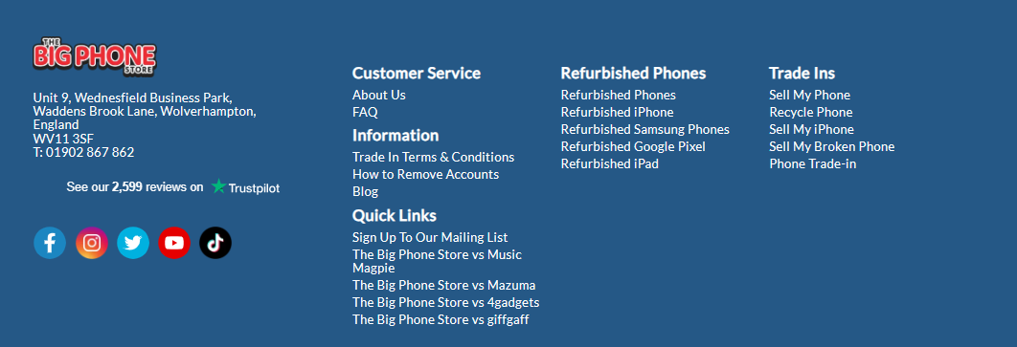

Cart/ Shopping Basket Button:

This button directs the user to the shopping basket page. This is where the users can choose a device they wish to buy or sell and it also provides them with the option to complete the orders in them by making payment or requesting for payment. It’s located at the top right corner of the heading on the website’s pages. 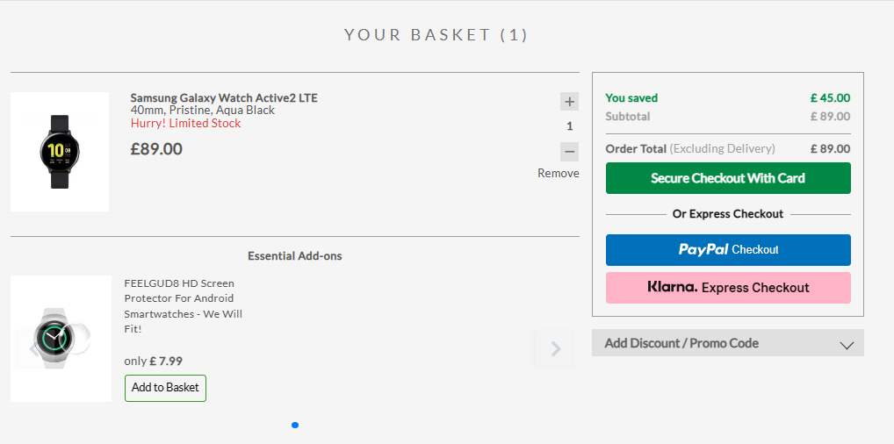



BASKET/CART

Hotspots:

Hotspots also known as ‘**invisible** **links** are spots or medias usually images that acts as hyperlinks on the website that directs you to another page or section when hovered over or clicked on. For example: On the homepage the images showing different phone models directs a user to the [sell my phone](https://www.thebigphonestore.co.uk/trade-ins/sell-my-phone) page.

Hotspots

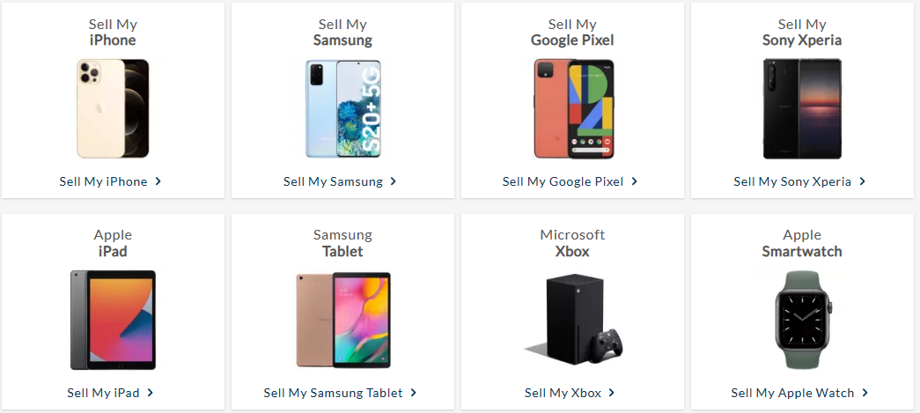

Search Bars:

This feature is used for searching for a specific keyword or a phrase such as for a phone model. This enhances the websites overall usability and allows for quick navigation to a specific product.

Contact/Support:

This feature allow users to contact customer supports, find information about issues, FAQs and also how to contact the company by mobile calling or sending a quote. This feature is located at the top of the website.

Contact/Support Section



Action Buttons:

Action buttons on the Big phone store website are levers that help users navigate and perform actions on the website. These buttons are created to be easy to use and identify by the users. Some examples of these action buttons are:





**Presentation:**

The presentation of the website is based on the big phone store brand’s identity and logo design. The red, dark/light blue and white colours are consistently associated with the brand. The creativity behind the website layout and colour scheme makes it suitable across all pages of the site and across all other presentation/ showcasing platforms of the company. Another benefit is that the colour scheme is that it allows easy viewing and navigation. The white background and spaces make it extremely important for any website, as it allows the user to view and understand information easily without getting distracted. The website does not promote or advertise any other product or business which makes it more appealing and distraction free. All these features make the website more presentable and attractive.

**Usability Review:**

From a user’s perspective the website navigation features such as the action buttons, hyperlinks/menus across the heading and footer of each page or section makes it easy for users to be able to move around the site without any issues. Due to the lack of consistency with links and dotted characters around the site, users with less computer knowledge or skill, disabilities may have difficulties navigating this website, as a result of the pathname in the URL on some pages.



**Accessibility:**

The Big phone website has no accessibility or any help link to support users with disabilities or difficulties. It’s shows that the web developer/designer have made a big error and this can be corrected by updating the site. As a result of no accessibility feature the website is going to provide a poor user experience for many users and can also be a violation of the accessibility laws and rules depending on the region or country.

**Performance:**

The performance of the big phone store website can also be checked in a user’s web browser. It starts by clicking on ‘**F12**’ to enter the ‘**developer tools**’, then navigate over to the performance bar and click ‘**Ctrl + E**’ to record it. and the frame performance of the big phone website is ‘**14344ms**’. This showcases that the big phone store website is very fast, and this improves the user experience and usability of the website.

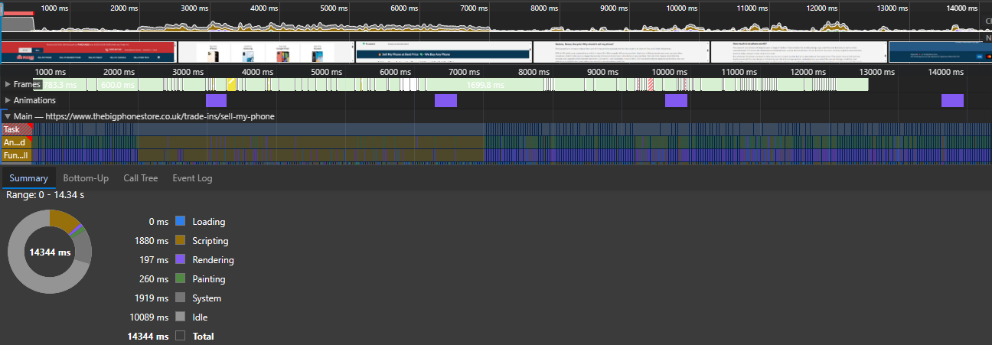

**Strengths:**

The strength of the big phone website is based on the navigation. The website’s layout is simple and straightforward and it’s extremely easy to navigate. The menus/hyperlinks are easy to access and none of the links are broken. The website also provides a convenient shopping experience that allows one click ordering and easy/multiple payment options that makes it easy for users to purchase products more efficiently. The website is also accessible on multiple devices such as mobile phones, tablets and PCs. The big phone website has got a lot of reviews and ratings for their products and services which builds up the customers trust and increases sales/customer engagement.

**Weakness:**

The greatest weakness of the big phone website is the lack of accessibility it shows how poor the user experience is going to turn out. Users with disabilities/difficulties will not be able to use or navigate the website which causes a decrease in customers engagement and sales. Just as I stated in the first report every website is subjected to technical faults or glitches, this can be caused as a result of few reasons such as security breaches, network failures, hosting/domain issues and so much more. Which can impact the user’ experience in every way. From my perspective, the big phone store menu style is out of date/style, these days most people prefer interactive hover/dropdown menu rather than a fixed one.

**Conclusion:**

Based on my report I think the big phone website is a powerful e-commerce website that offers so many benefits to customers in every aspect. Although, the website has a lot of weakness and features to improve on, especially the accessibility aspects. Without considering all these options (**weakness**) the company will slowly start to lose customer and decrease in sales/profits or revenues.